***SMART COLLEGE***

*A*

*Project Report*

*Submitted in partial fulfilment of the*

*Requirements for the award of the Degree of*

**BACHELOR OF ENGINEERING**

IN

**INFORMATION TECHNOLOGY**

By

**MIRYALA ROHITH (1602-19-737-089)**

**BARDA SAI KUMAR REDDY (1602-19-737-094)**

**M.AKASH REDDY (1602-19-737-063)**

*Under guidance of*

**KEZIA RANI**

**Professor**



**Department of Information Technology**

**Vasavi College of Engineering (Autonomous)**

**(Affiliated to Osmania University) Ibrahimbagh,**

**Hyderabad-31 2021-2022 Vasavi College of Engineering (Autonomous)**

**(Affiliated to Osmania University) Ibrahimbagh, Hyderabad-31**

**Department of Information Technology**



**DECLARATION BY THE CANDIDATES**

We, **M. ROHITH, B.SAI KUMAR, M. AKASH** bearing hall ticket numbers, **1602-19-737-089, 1602-19-737-094, 1602-19-737-063** hereby declare that the project report entitled “**SMART COLLEGE**” under the guidance of **KEZIA RANI**, Professor, Department of Information Technology, Vasavi College of Engineering, Hyderabad, is submitted in partial fulfilment of the requirement of MINI PROJECT of V semester of **Bachelor of Engineering in Information Technology**.

This is a record of bonafide work carried out by us and the results embodied in this project report have not been submitted to any other university or institute for the award of any other degree or diploma.

**MIRYALA ROHITH (1602-19-737-089)**

**BARDA SAI KUMAR REDDY (1602-19-737-094)**

**M.AKASH REDDY (1602-19-737-063)**

**Vasavi College of Engineering (Autonomous)**

**(Affiliated to Osmania University) Ibrahimbagh, Hyderabad-31**

**Department of Information Technology**



**BONAFIDE CERTIFICATE**

This is to certify that the project entitled " **SMART COLLEGE**” being submitted by **M. ROHITH, B.SAI KUMAR, M. AKASH** bearing **1602-19-737-089, 1602-19-737-094, 1602-19-737-063** in partial fulfilment of the requirements for the completion of MINI PROJECT of Bachelor of Engineering in Information Technology is a record of bonafide work carried out by them under my guidance.

**KEZIA RANI Dr. K. Ram Mohan Rao**

**Professor HOD, IT**

**Internal Guide**

**ACKNOWLEDGEMENT**

The satisfaction that accompanies that the successful completion of the project would not have been possible without the kind support and help of many individuals. We would like to extend my sincere thanks to all of them. We would like to take the opportunity to express our humble gratitude to **KEZIA RANI** (Professor) under whom we executed this project. We would also use this opportunity to thank our Head Of Department Dr. K.Ram Mohan Rao. We would also like to thank all faculty members and staff of the Department of Information Technology for their generous help in various ways for the completion of this project.

Finally, we would like to express our heartfelt thanks to our senior **M W Farooqui Junaid (1602-17-737-020)**. We are grateful to his guidance, and constructive suggestions that helped us in the preparation of this project. His constant guidance and willingness to share his vast knowledge made us understand this project and its manifestations in great depths and helped us to complete the assigned tasks.

**ABSTRACT**

As an Engineer we solve hundreds of problems in our day-to-day life through various technologies. But today we as a group came forward with an idea which helps many Engineers to build their careers with confidence.

The Concept of smart college can one be of the emerging trend in ML in coming up years where the thought of ‘Smart Campus, Secure Campus’ may become the new mantra. Our project focus on helping the management for taking quick attendance and it also help teachers to predict which student can be able to get a placement or not. This project is also helpful in knowing about the college for newly joined students through an interactive chat bot. Furthermore, the project will present and discuss an idea about smart college using the concepts of Machine Learning.

**INDEX**

**CHAPTER 1**

**Title and Description 1**

1.1 Motivation 1

**CHAPTER 2**

**Software Requirements Specifications 2**

2.1 Introduction 2

2.1.1 Purpose 2

2.1.2 Scope 2

2.1.3 Definitions, Acronyms and Abbreviations 2

2.1.4 Overview 2

2.2 General Description 3

2.2.1 Product Perspective 3

2.2.2 Product Functions 3

2.2.3 User Characteristics 3

2.3 Modules Description 3

2.4 System Requirements 4

2.4.1 Hardware Requirements 4

2.4.2SoftwareRequirements 4

2.5DesignConstarints 5

**CHAPTER 4**

**System Design 6**

4.1 Architecture and Technology used 6

4.2 UML Diagrams 7

4.2.1 Use-case Diagram 7

4.2.2 Sequence Diagram 8

**CHAPTER 5**

**Implementation 9**

5.1 System Architecture (design) 9

5.2 Implementation and code 9

**CHAPTER 6**

**Results 10**

6.1 Database Design 20

**CHAPTER 7**

**Testing 21**

**CHAPTER 8**

**Conclusion and Future Scope 22**

**CHAPTER 9**

**References 23**

# CHAPTER 1

# TITLE DESCRIPTION

Smart College is a web application which we have developed to provide a platform to students who are lacking the interaction with the other students and adapting to the college environment needed at present and are willing to adapt those skills. Our projects help them to learn about their standards using placement prediction module.

### 1.1 Motivation

A normal student will always be perplexed about their future. The way he/she must prepare for their goals. The way he/she must update him/herself every day. In the ever-growing world with a new upcoming technology striking us every day it really is a challenge for any student to cope up with the amount of competition to secure their jobs currently. Smart College will help these students to learn the required courses for the interviews with a group learning facility and understanding where the standard with respect to current situation. It also helps the teachers to digitalize the manually taken attendance.

# CHAPTER 2

# SOFTWARE REQUIREMENTS SPECIFICATIONS

## 2.1 Introduction

#### 2.1.1 Purpose

In search of proper platform that makes the college to digitalize completely from the attendance to placement prediction of a particular given student with respect to his skills.

#### 2.1.2 Scope

With the help of this website users(students) will be able to stabilize their thoughts on how to prepare for the interviews and what to prepare. With ever-growing technologies and a new course showing up every day. Teachers work also reduces on a huge amount of daily basis attendance in an accurate manner.

#### 2.1.3 Definitions, Acronyms and Abbreviations

#### 2.1.4 Overview

The specifications include product perspective and the functionalities that the system will provide. The user characteristics, any general constraints or assumptions and dependencies are discussed below.

Requirements are categorized as performance, non-functional requirements, and design constraints. Non-functional requirements are scalability, maintainability, and dependence.

## 2.2 General Description

#### 2.2.1 Product perspective

Smart College provides features for client users such as E-college i.e., accessing the online attendance feature and prediction of their standards of skills. The current design goal is to build a system to achieve the functionality outlined in the specification.

#### 2.2.2 Product Functions

Smart College gives users a online attendance portal and placement prediction module for students.

#### 2.2.3 User Characteristics

1. **Student/user:** 
   * + The user can register in our website free of cost.
     + He/she can and access the features after logging in.
2. **Administrator:** 
   * + Admin is responsible for maintaining and updating website
     + Admin has access to database.

## 2.3 Modules Description

* **Login/Signup:**

In this module, the user can log into their respective accounts and use the website as desired. If the student is not an already existing user, he/she can create a new account by signing up.

* **Face Attendance:**

Here, the teacher can access the camera and take attendance using camera instead of manual book attendance format.

* **Placement Prediction:**

A student can predict his standards regarding placements by giving required inputs to the ML model which predicts his standards with 78% accuracy.

## 2.4 System Requirements

#### 2.4.1 Hardware Requirements

* 1GB RAM
* 1GB CORE

#### 2.4.2 Software Requirements

* **PYCHARM – 2021.3:**

PyCharm is an integrated development environment or IDE. An IDE is the primary tool for any professional programmer. PyCharm acts like a true IDE for Python, but unlike Visual Studio, PyCharm is geared specifically and only for Python development. It contains workflows for creating and maintaining virtual environments, a visual counterpart for the Pep library manager, linters that keep your code compliant with Pep 8 standards and a host of other handy general development tools.

* **INTERPRETER:**

Visual Studio Code- It features a lightning-fast source code editor, perfect for day-to-day use. With support for hundreds of languages, VS Code helps you be instantly productive with syntax highlighting, bracket-matching, auto indentation, box-selection, snippets, and more.

* **PYTHON-FLASK:**

**Flask Framework:**

**Flask** is a microweb framework written in python. It is classified as a microframework because it does not require tools or libraries. It has no database abstraction layer, form validation, or any other components where pre-existing third-party libraries provide common functions. However, Flask supports extensions that can add application features as if they were implemented in Flask itself. Extensions exist for object-relational mappers, form validation, upload handling, various open authentication technologies and several common framework related tools.

• **BOOTSTRAP- WEB DESIGNING:**

Bootstrap is a free and open-source front-end framework for designing websites and web applications. It contains HTML- and CSS-based design templates for typography, forms, buttons, navigation and other interface components, as well as optional JavaScript extensions.

## 2.5 Design Constraints

* Software Constraints: Users can run this application in windows.
* Hardware Constraints: The system will run on a core processor with minimum 400MB ram.
* Acceptance Criteria: Before accepting, the developer must check whether the application is running properly or not and should also check whether the data is stored correctly.

**CHAPTER 4 SYSTEM DESIGN**

**4.1 Architecture and Technology Use**

**Front-End:**

1. HTML
2. CSS
3. JAVA SCRIPT 4) BOOTSTRAP

**Back-End:**

1. SQLlite3
2. FLASK

**Overall Architecture:**

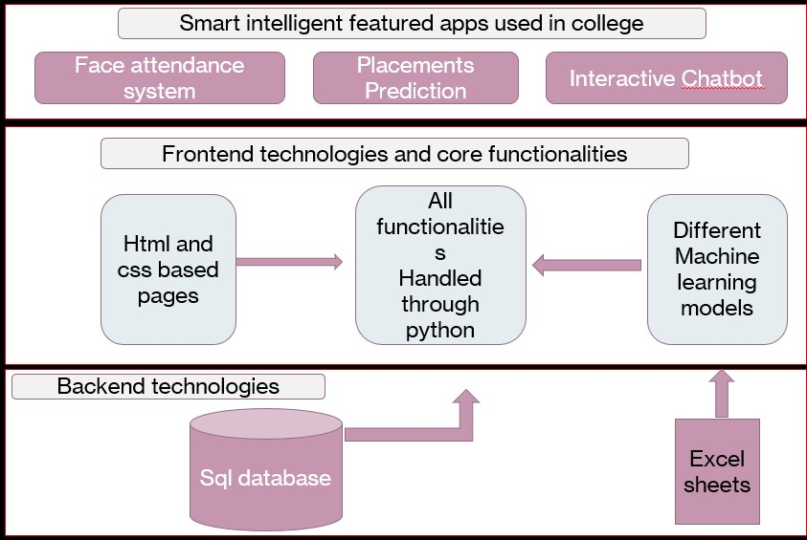

**4.2 UML Diagrams**

* + 1. **Use-case Diagram**

Use case diagrams are the diagrammatic representations depicting users' interactions with the system. This diagram shows different types of users and various ways in which these users interact with the system.

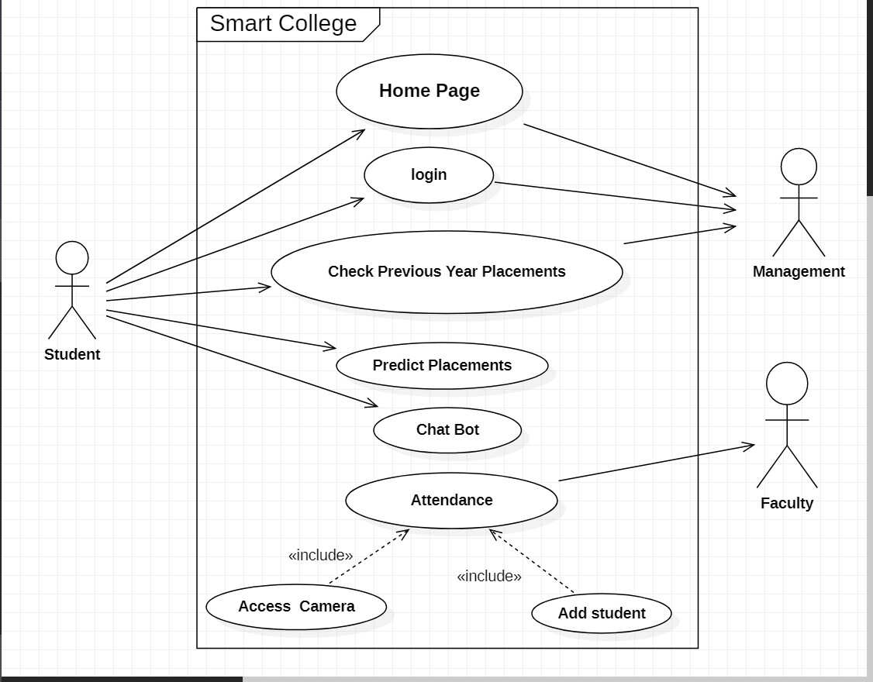

* + 1. **Sequence Diagram**

Sequence diagrams establish the roles of objects and help provide essential information to determine class responsibilities and interfaces. This type of diagram is best used during early analysis phases in design because they are simple and easy to comprehend. These are normally associated with use cases and are closely related to collaboration diagrams, and both are alternate representations of an interaction.

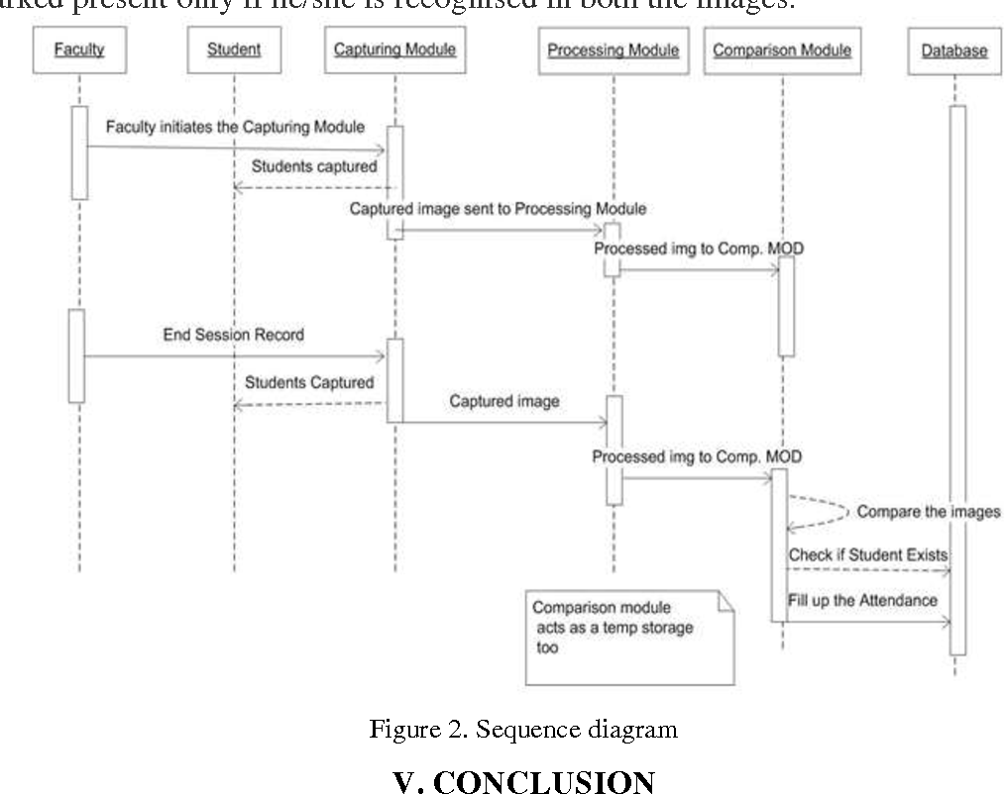

**CHAPTER 5**

**IMPLEMENTATION**

* 1. **System Architecture (Design)**

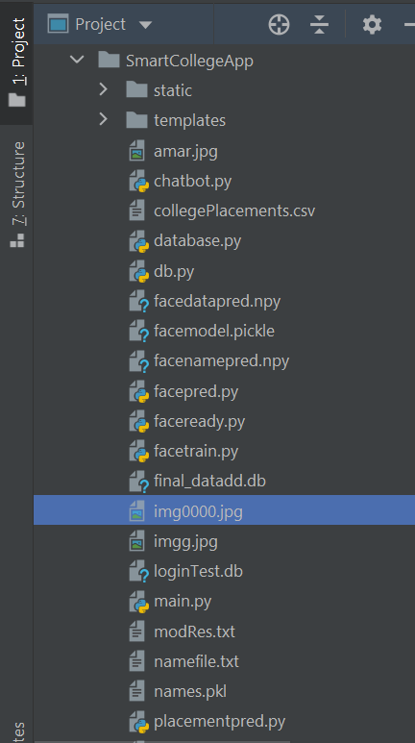

* 1. **Implementation and code:**

**Github link:**[**https://github.com/MiryalaRohith/SMART-COLLEGE.git**](https://github.com/MiryalaRohith/SMART-COLLEGE.git)

**CHAPTER 6**

**RESULTS**

**Home Page:**

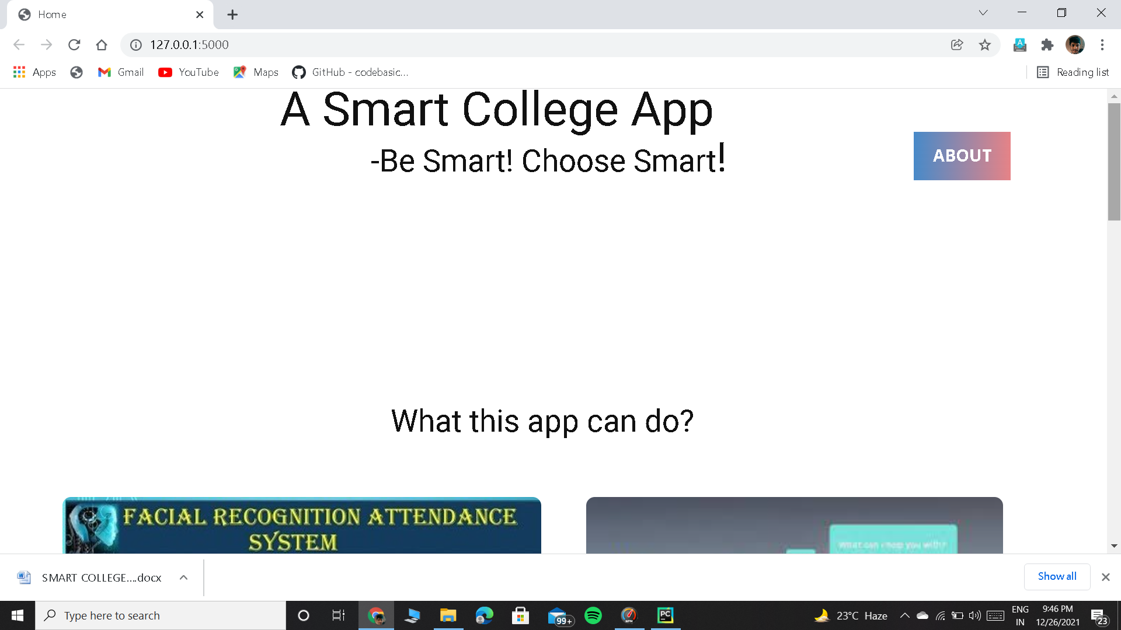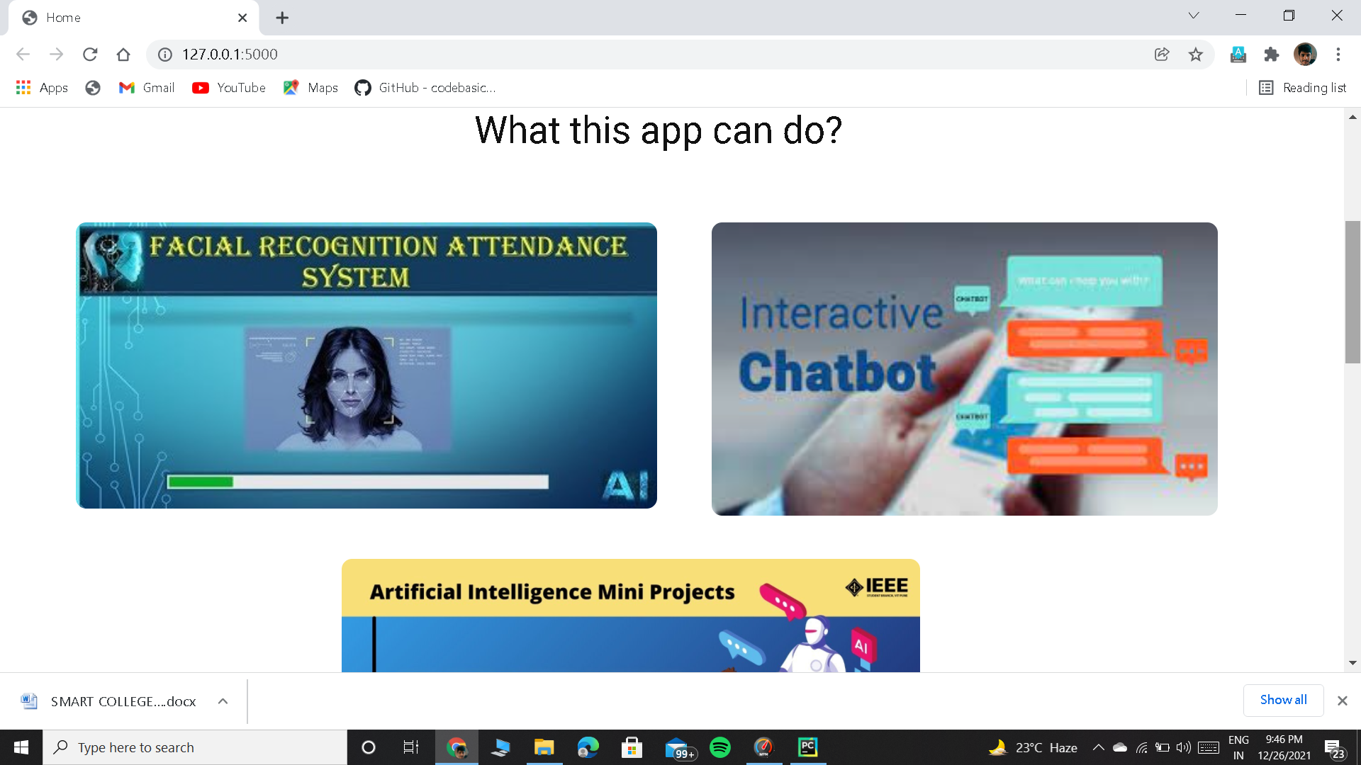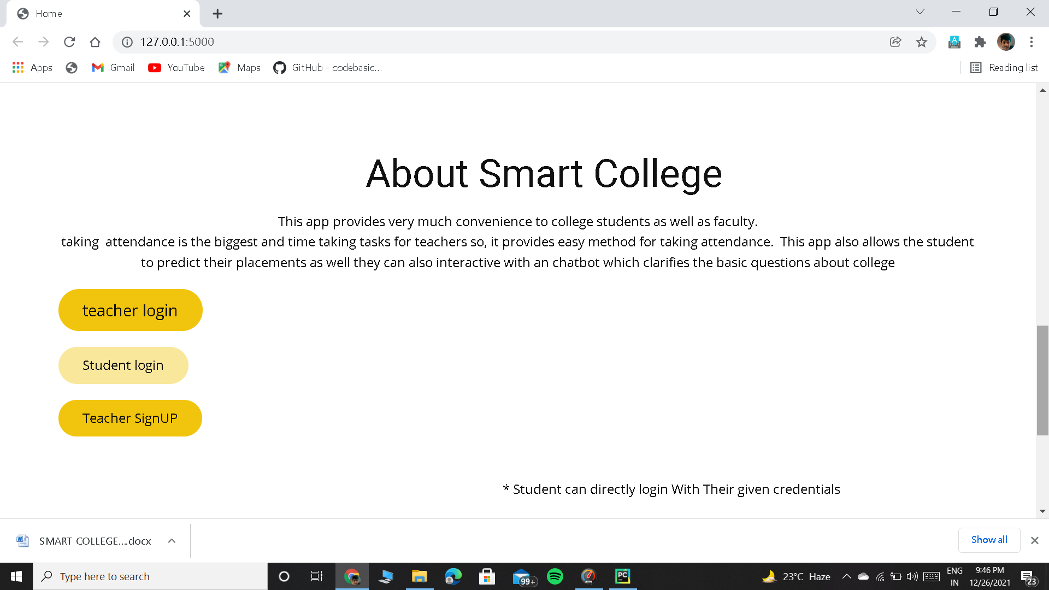

**Login Page**

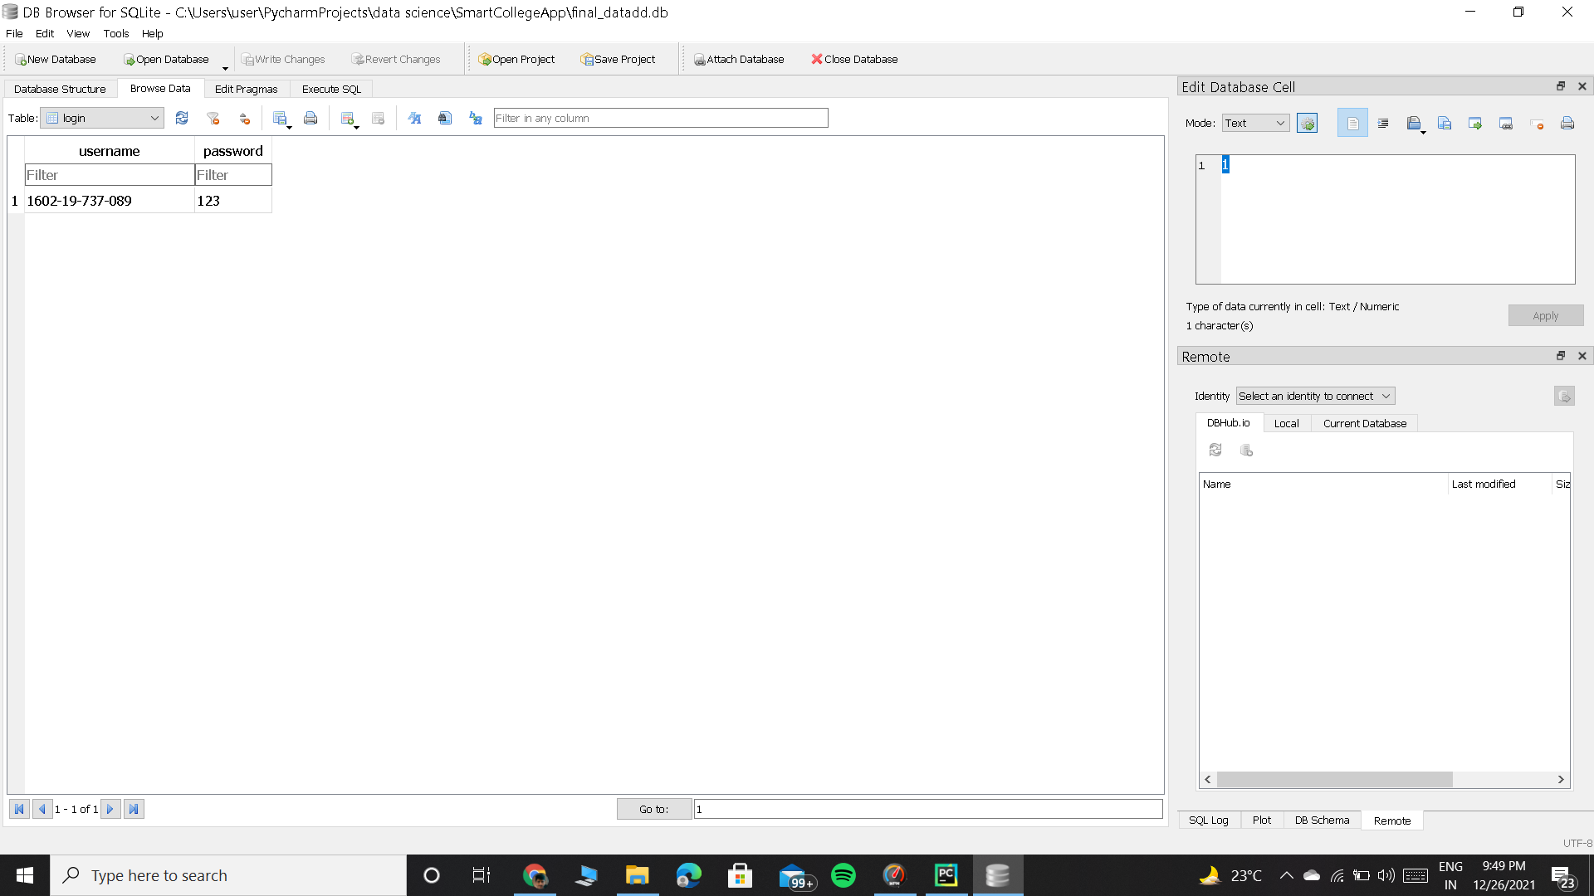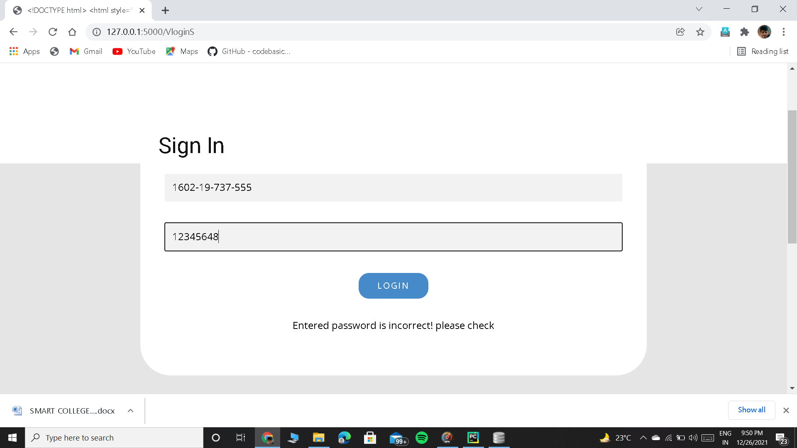

**Student page:**

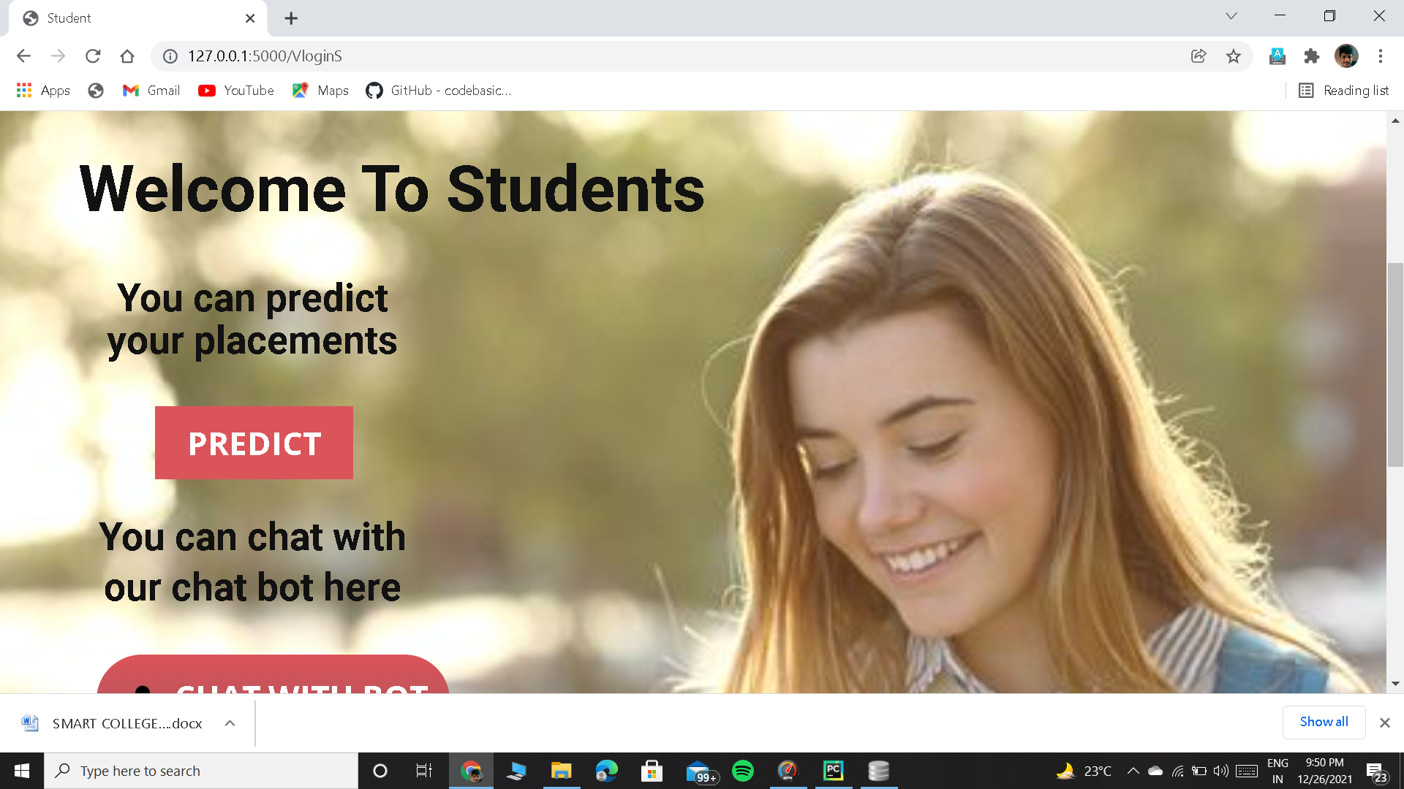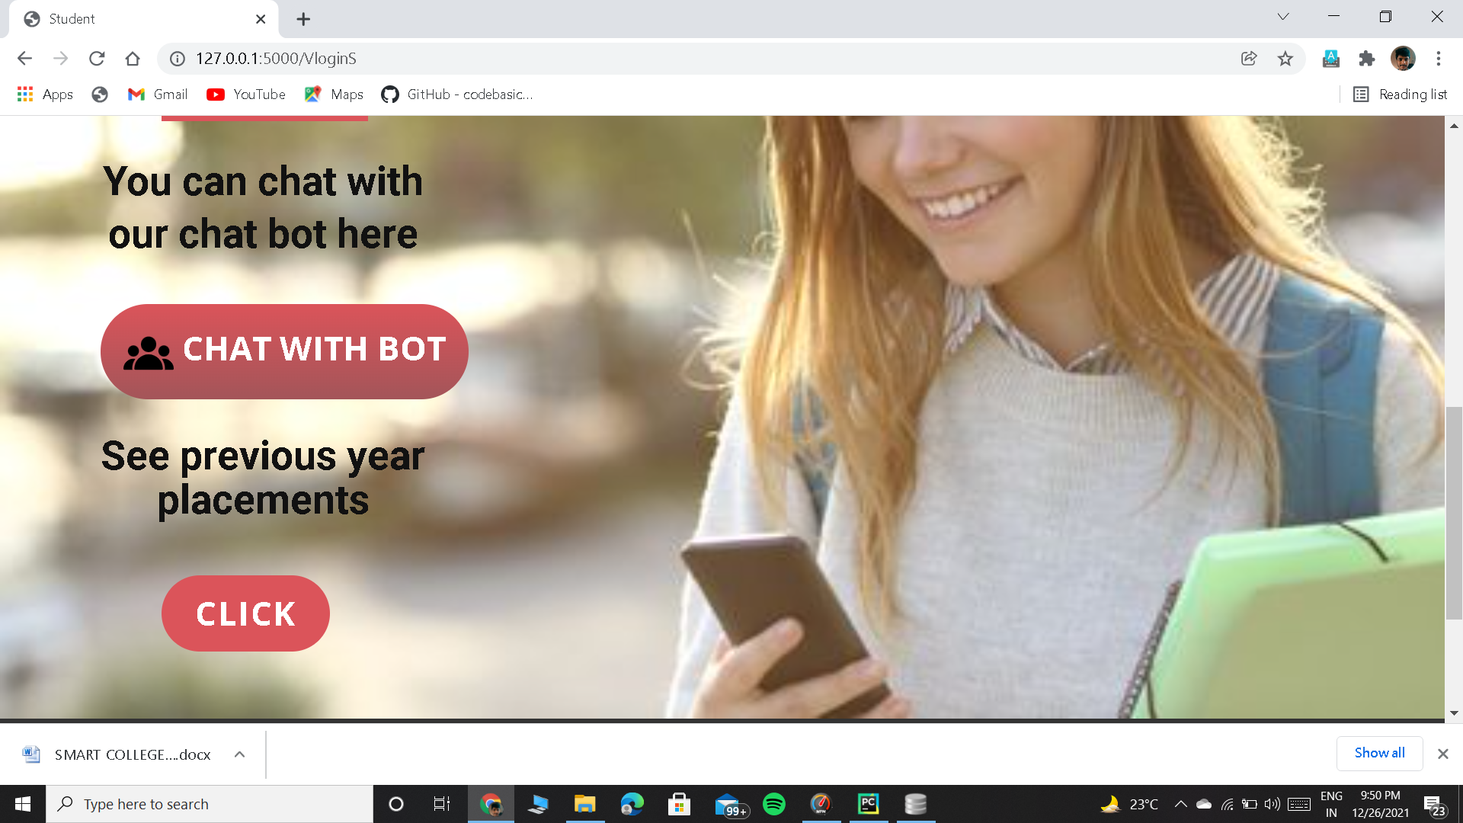

**Placement Prediction**

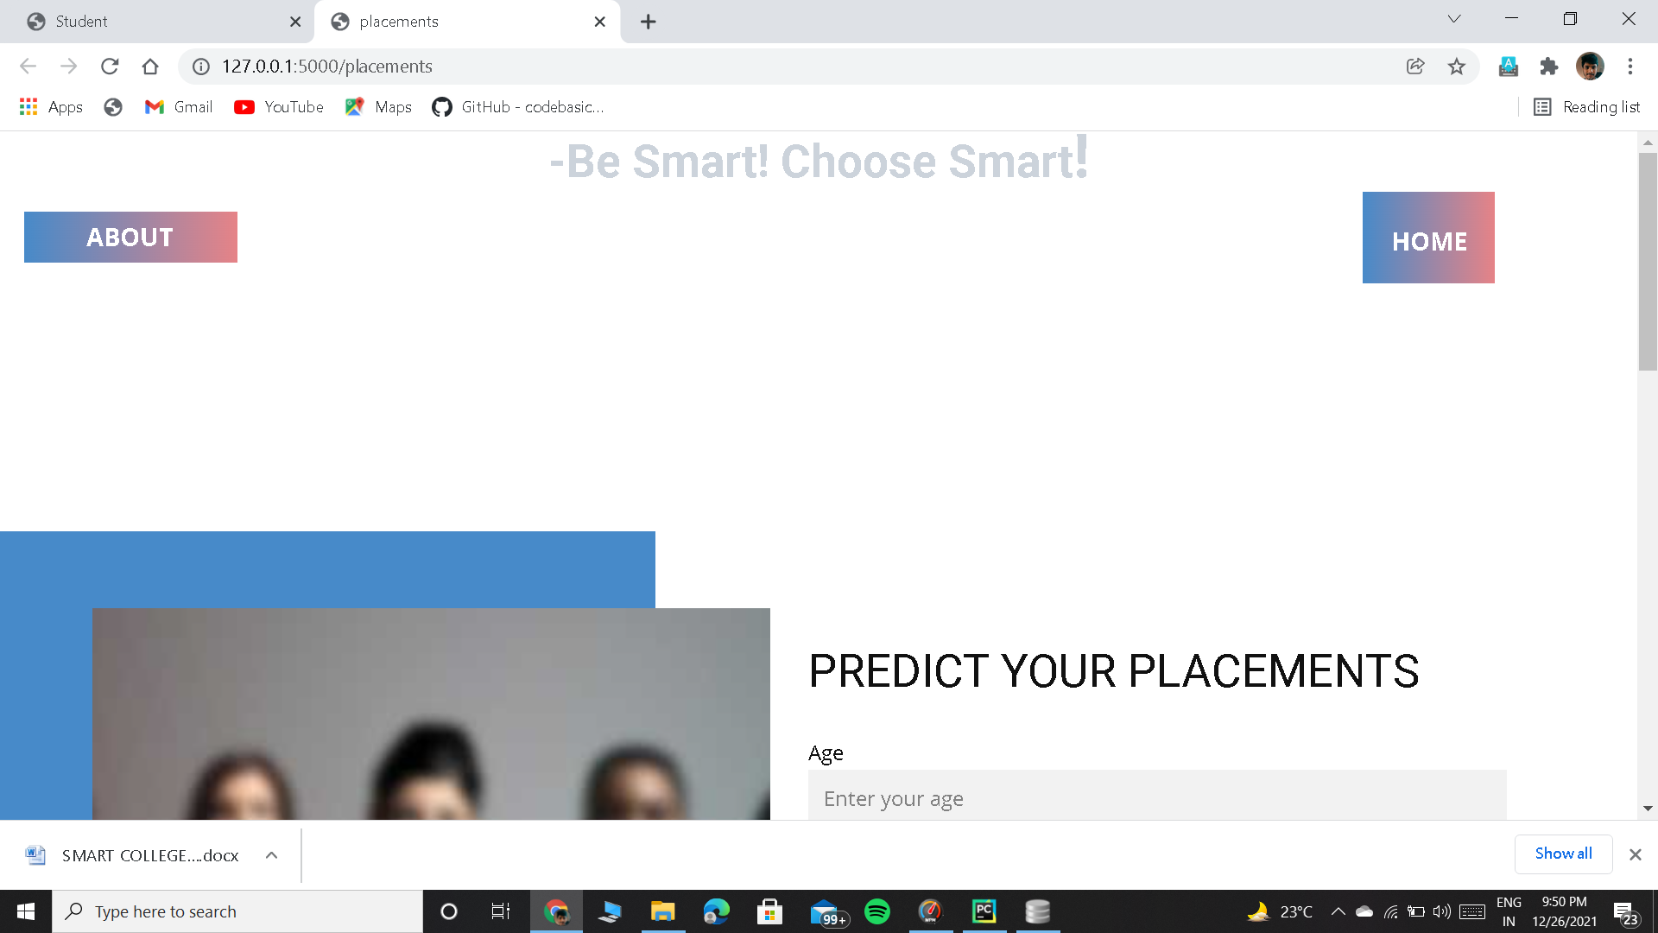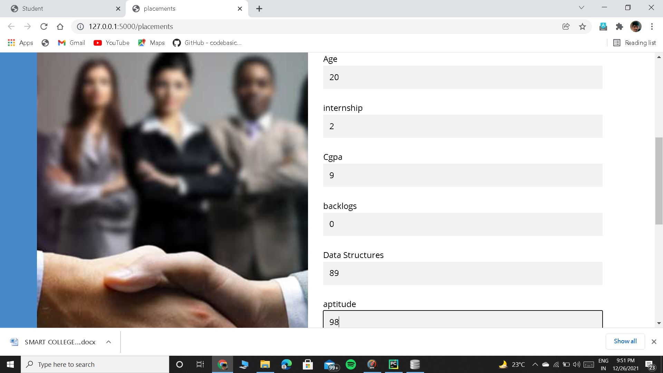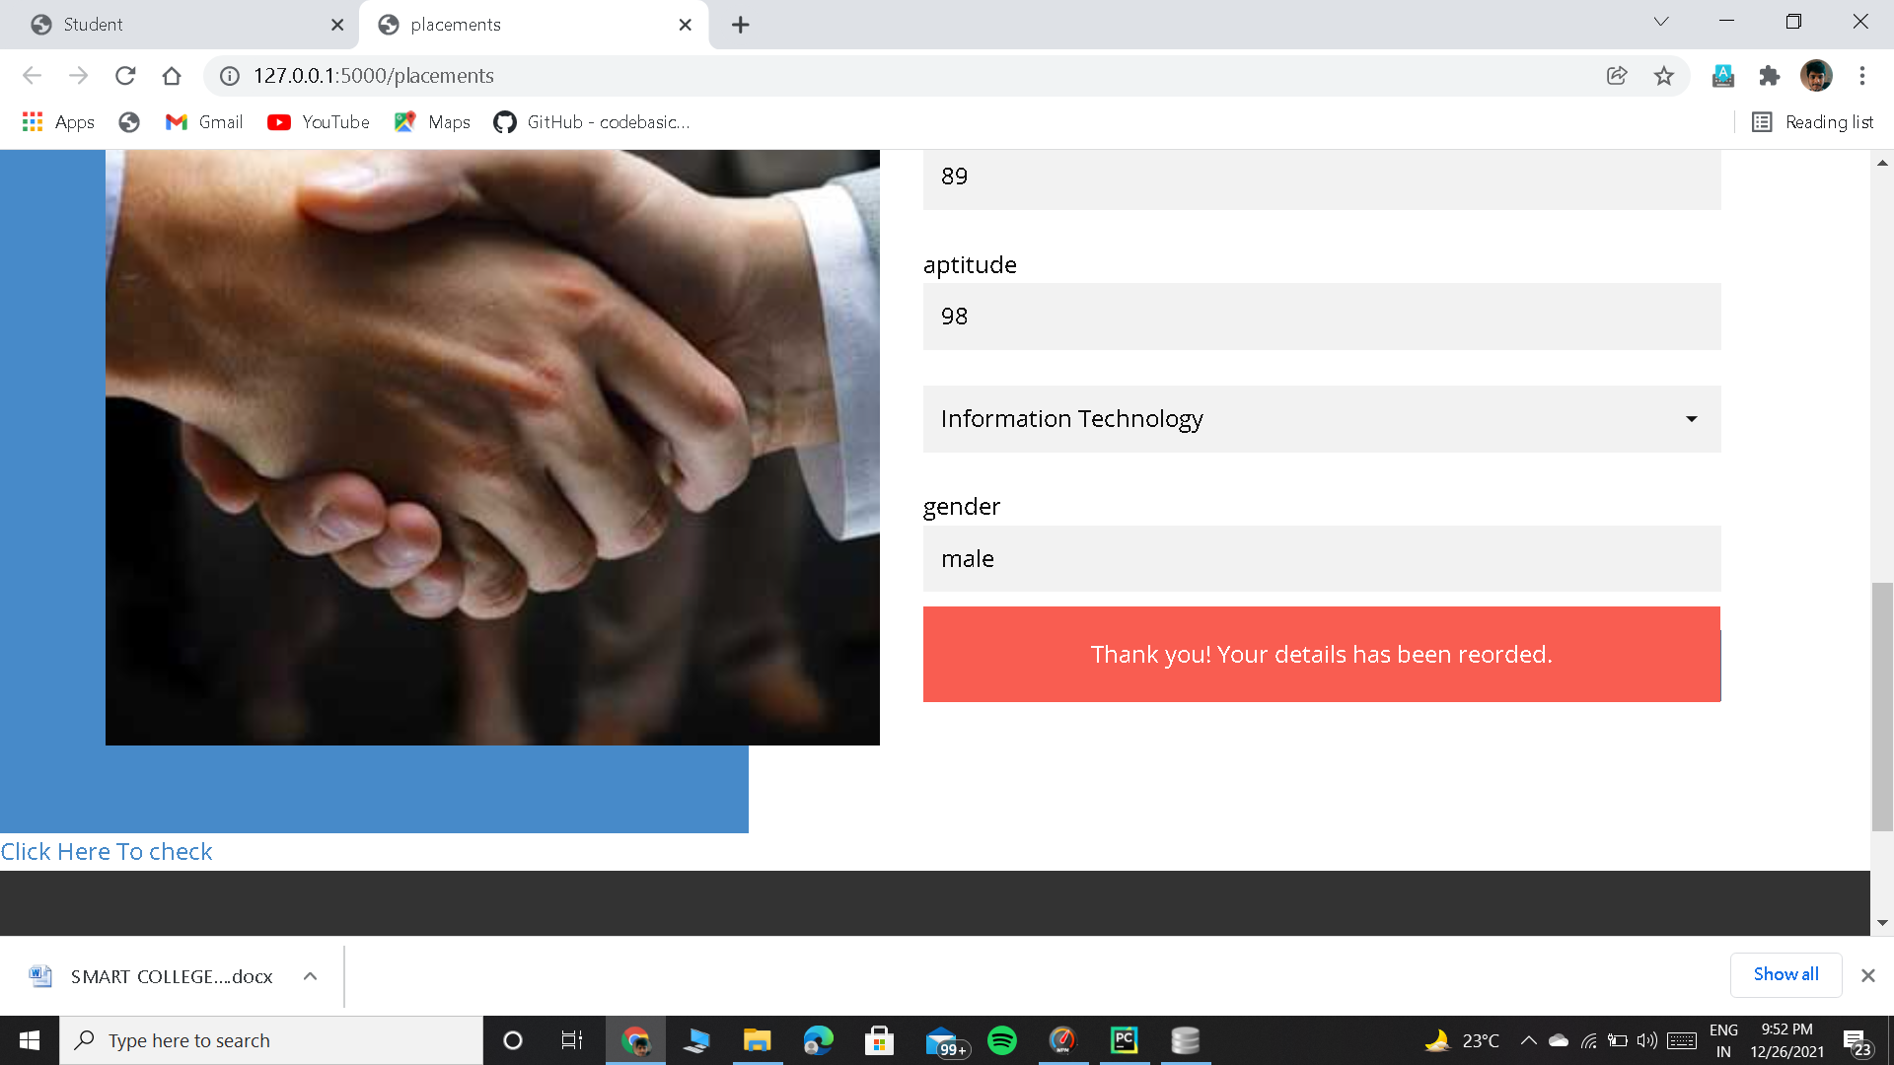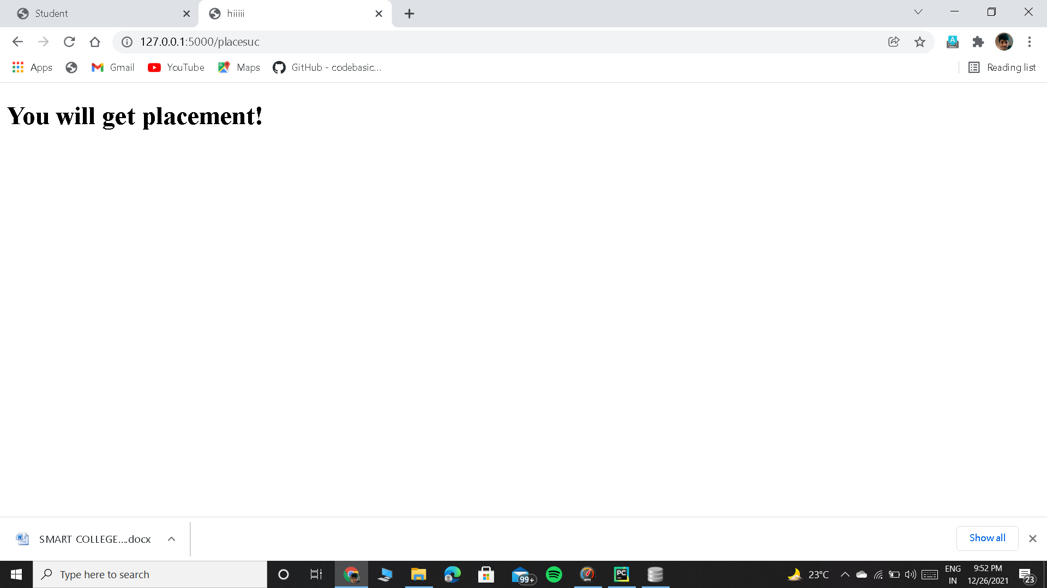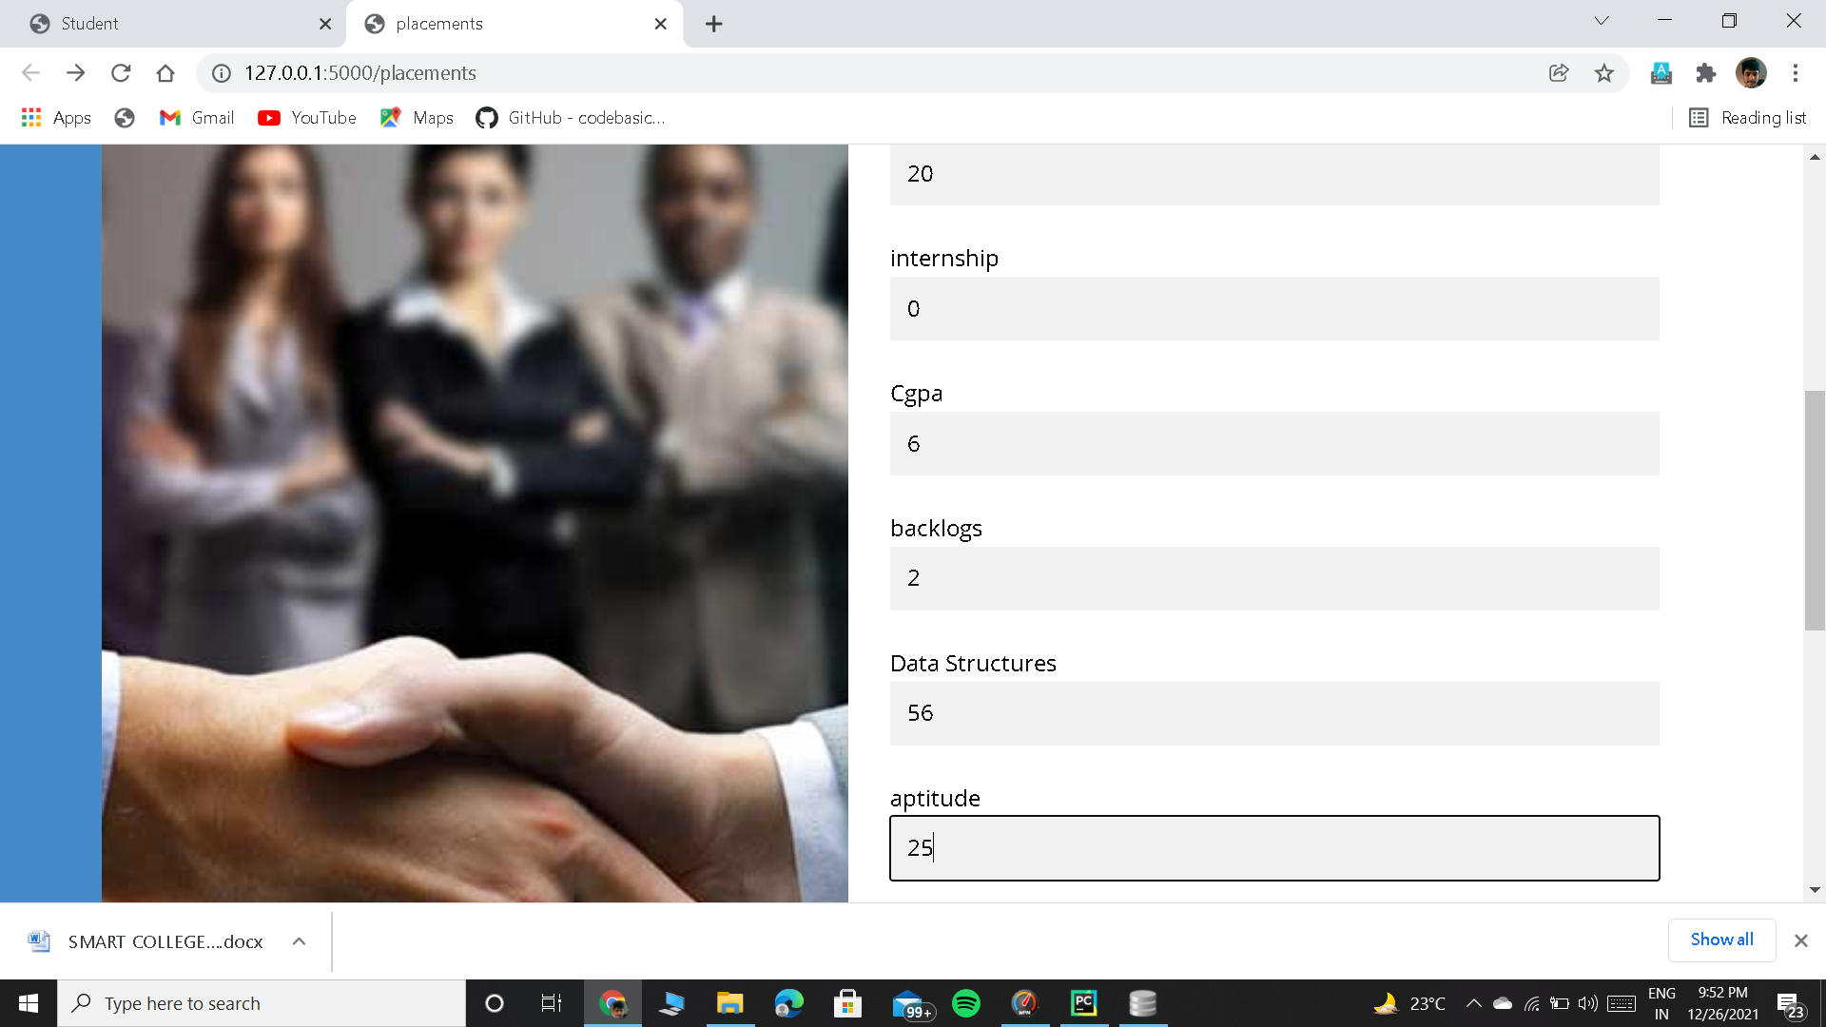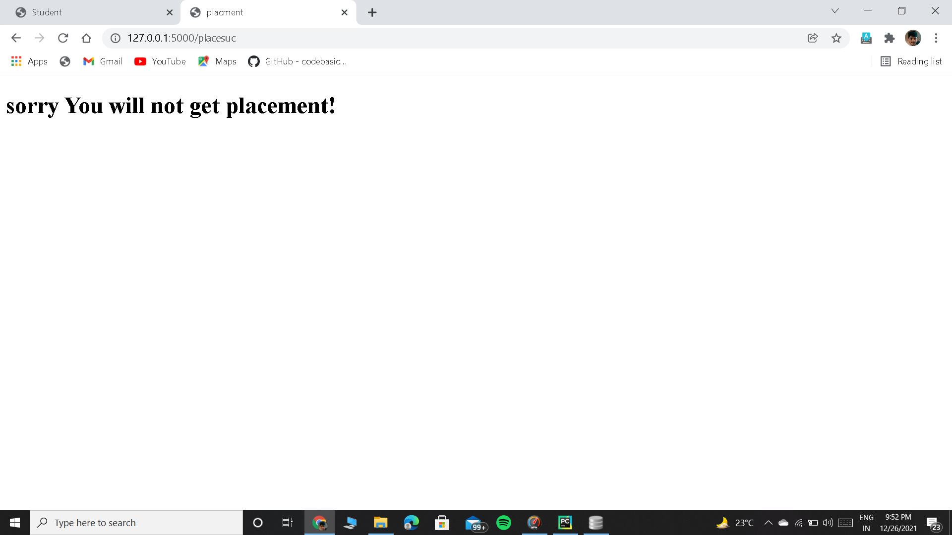

**Teacher Signup**

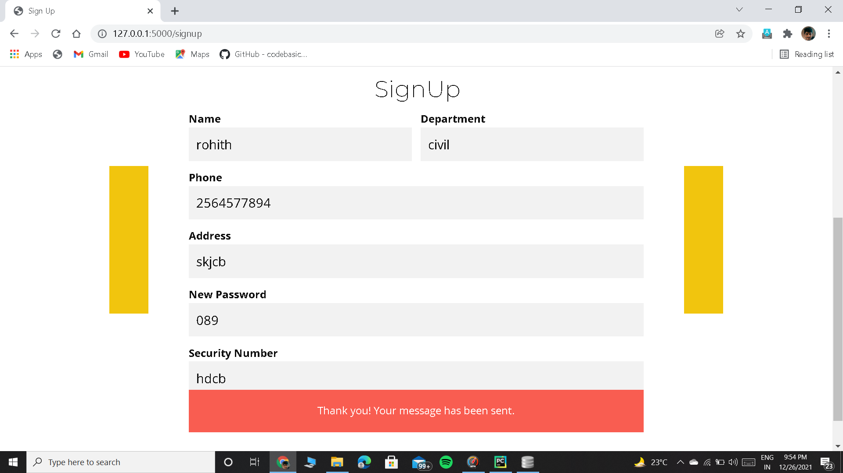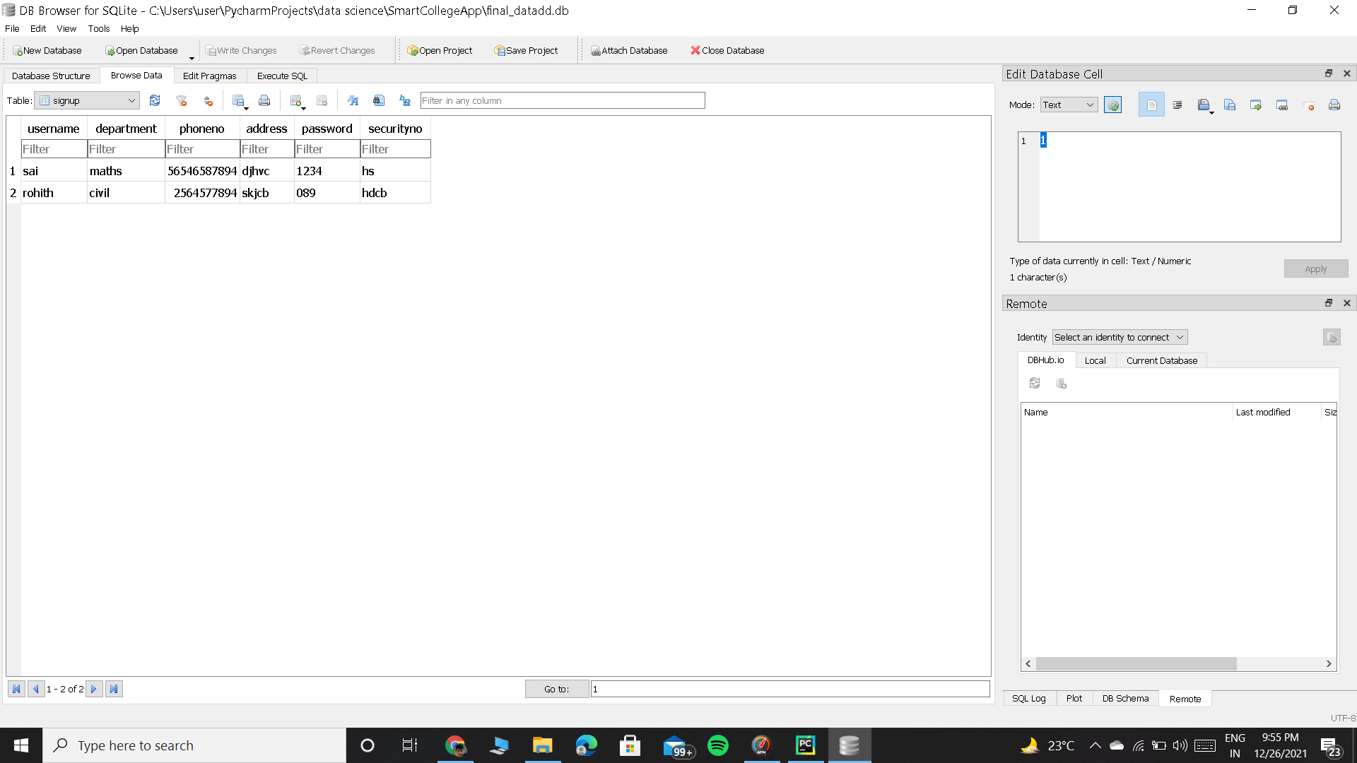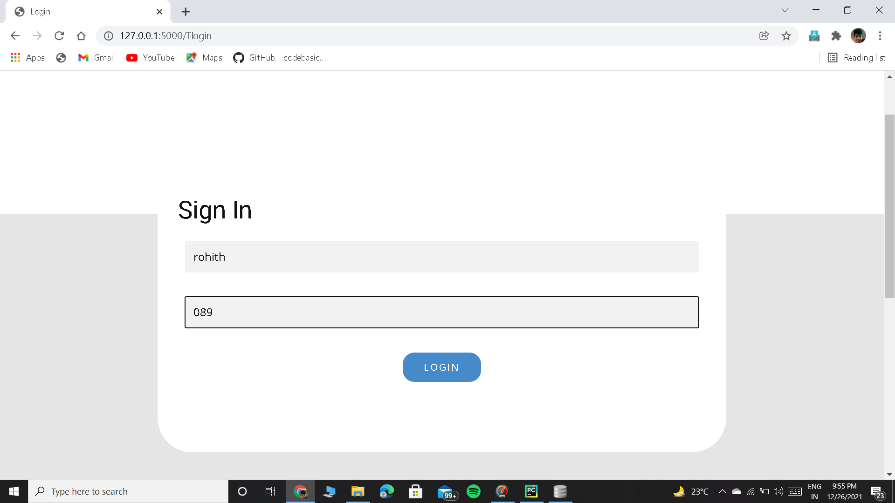

**Teacher Home Page**

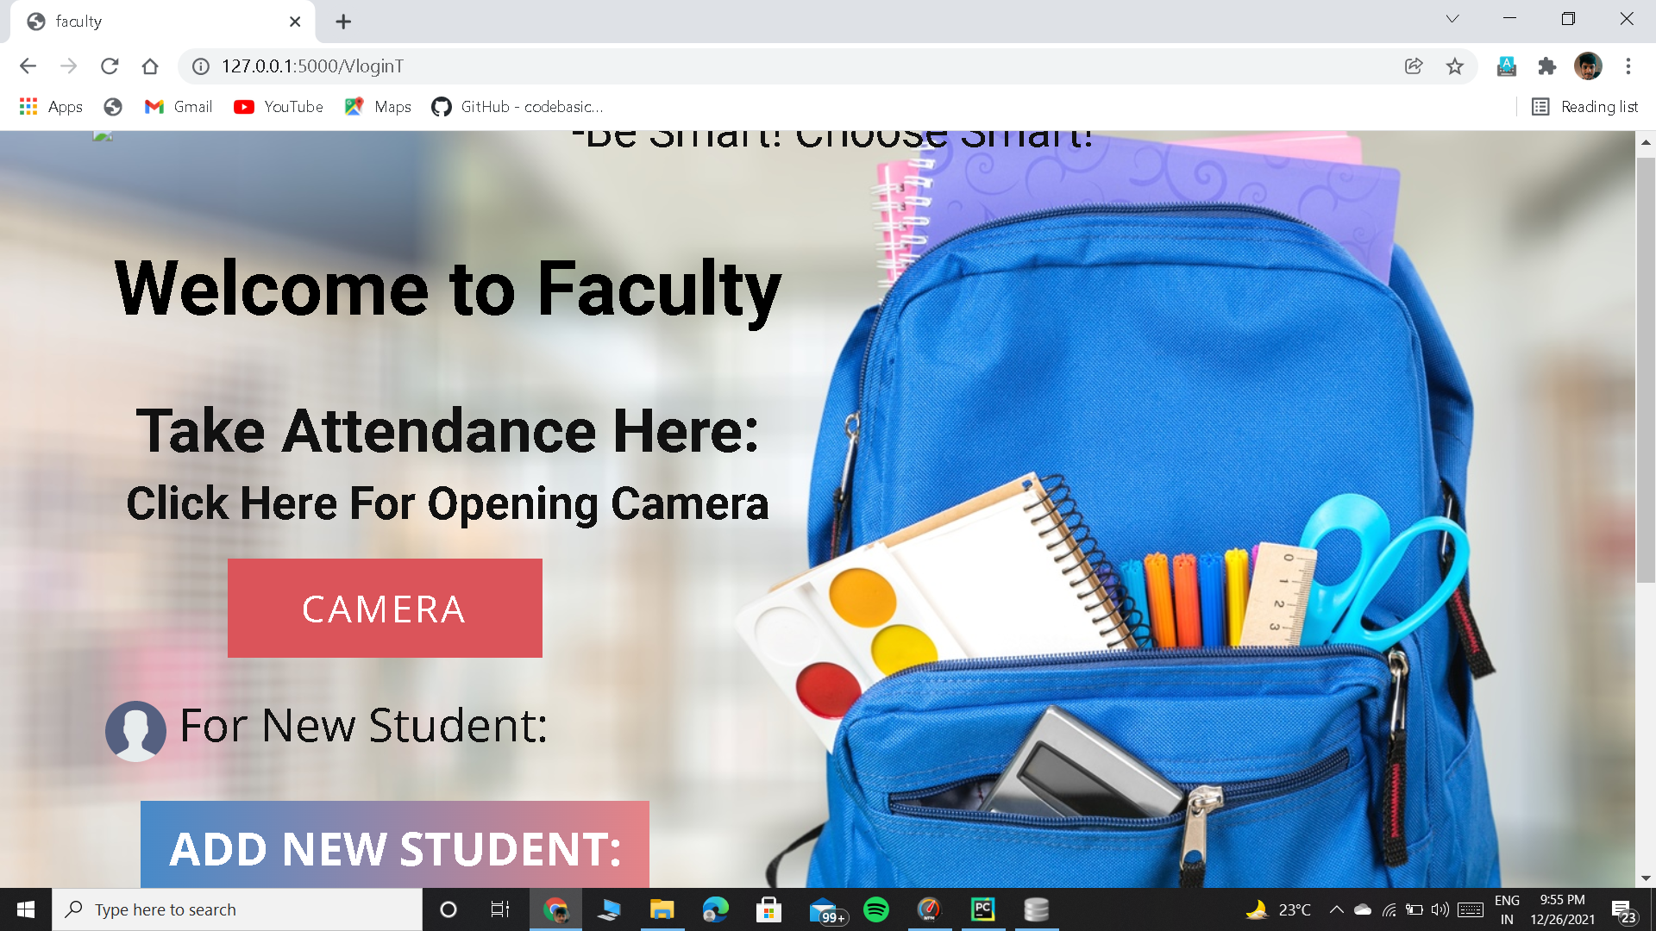

**Teacher capturing the image**

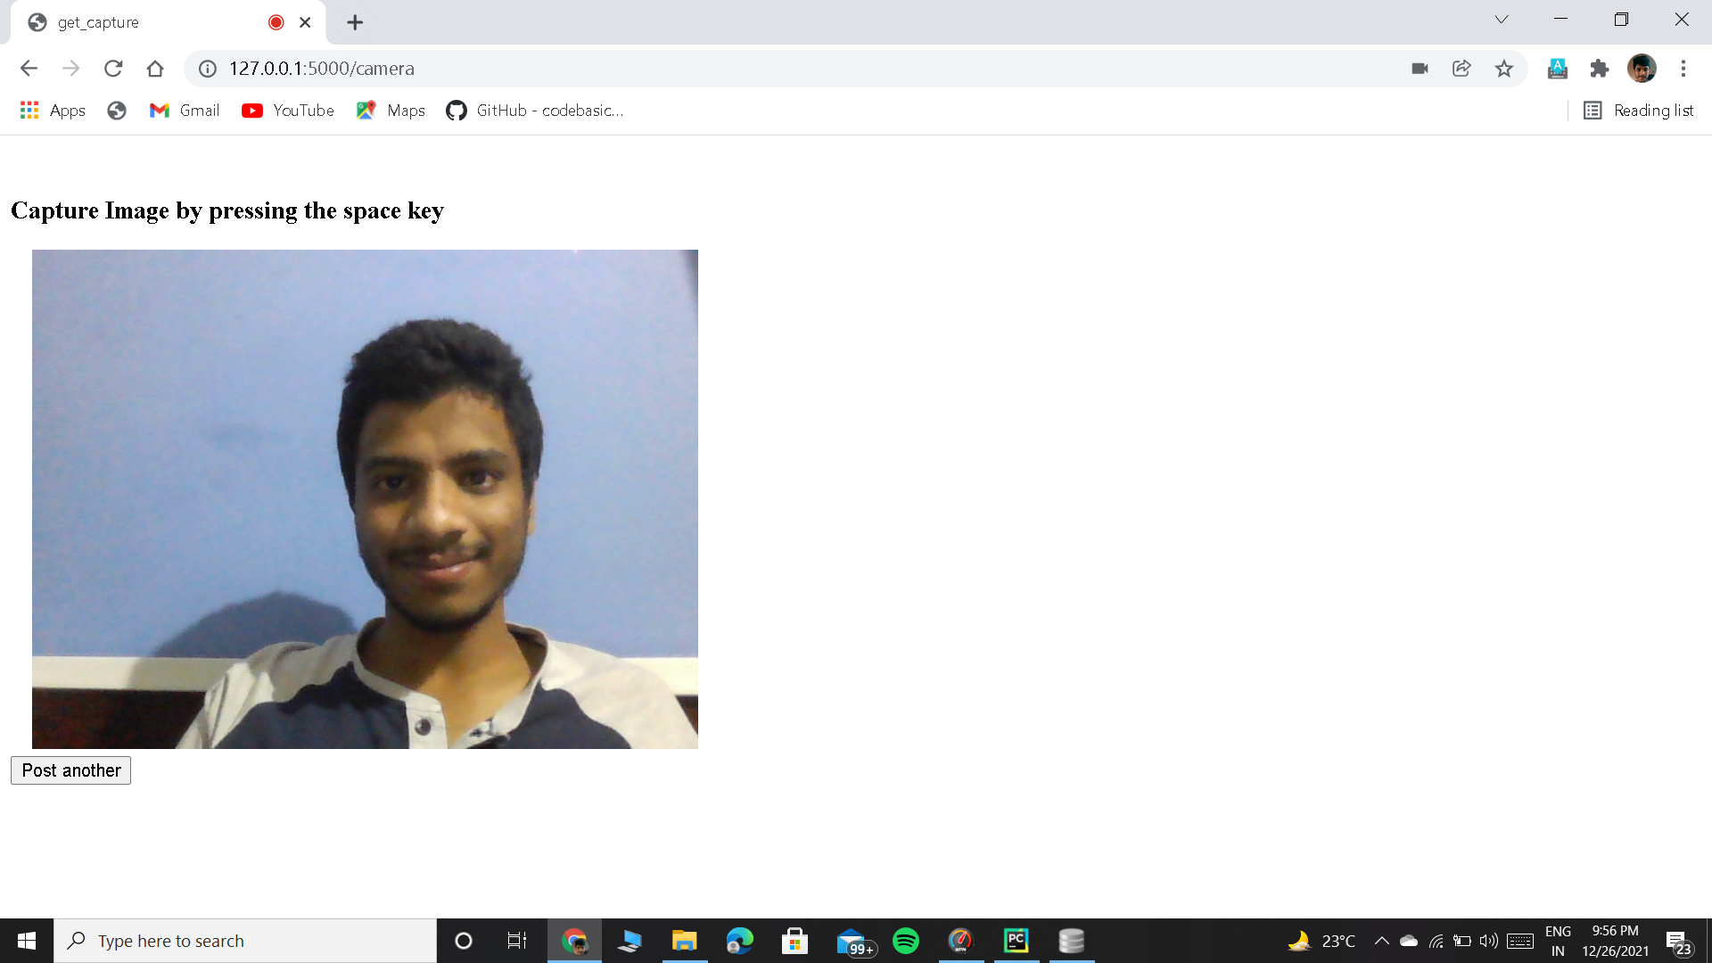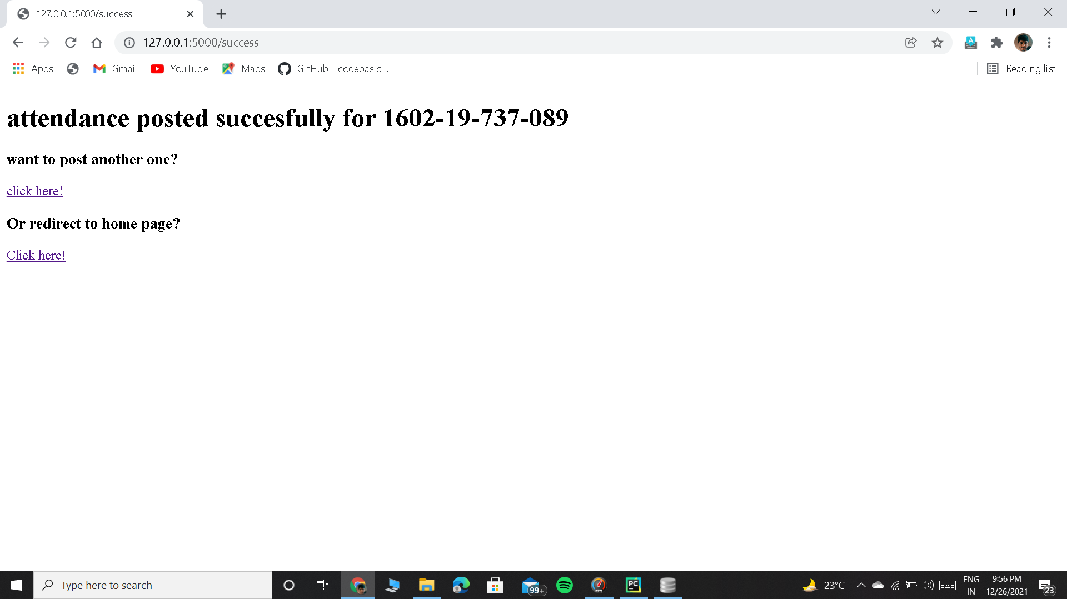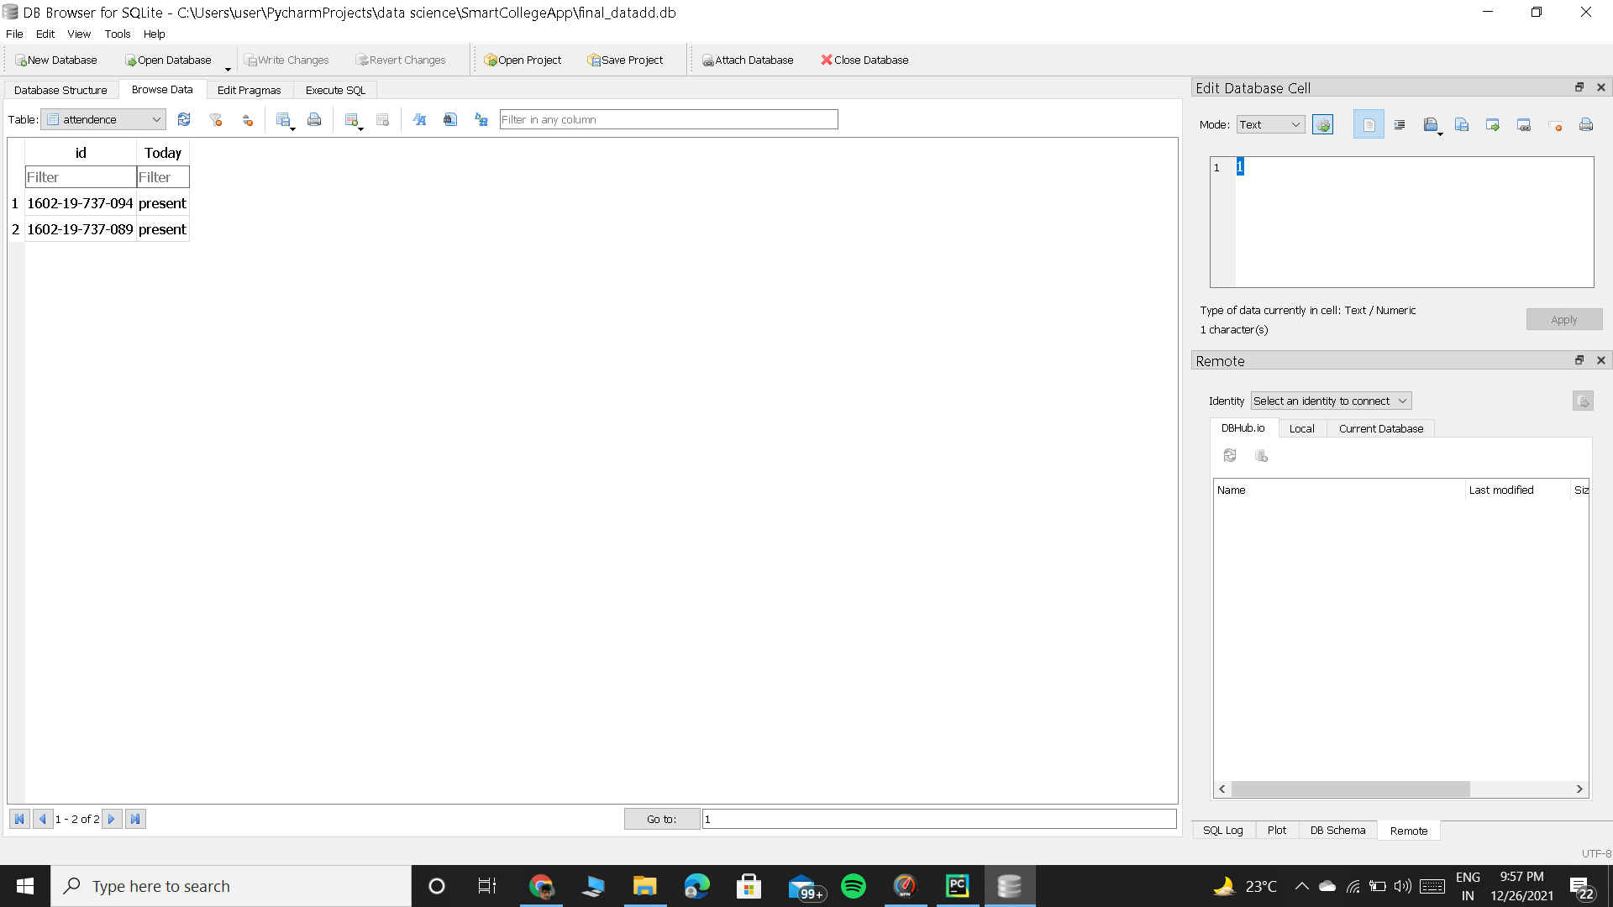

**6.1 Database Design:**

**(Mysqllite3)**

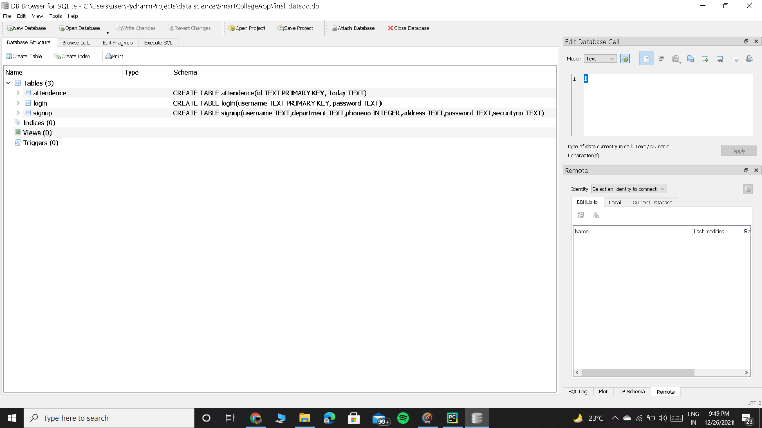

**CHAPTER 7**

**TESTING**

* Password is validated using flask built in password hashing mechanism.
* Phone number is validated by checking the pattern=[0-9]{3}-[09]{3}-[0-9]{4} at admin input side using <input type="tel" pattern="[0-9]{3}-[0-9]{3}-[0-9]{4}">
* A valid teacher details are checked by comparing correct Enrolment date and enrolment number with the database values at the admin side.

**CHAPTER 8**

**CONCLUSION AND FUTURE SCOPE**

**Conclusion:**

We believe that our website will be helpful for students and teachers who have or do not have any experience. Our website will be a one- stop-place to track attendance, for client users and will build a bridge between students and the peers.

**Future scope:**

* An efficient chat system between the student and the chatbot can be introduced.
* Language translator can be introduced into the website so that people who are not comfortable with English can use.
* Based on the feedback from the user(s) modifications on the website can be done.

**CHAPTER 9**

**REFERENCES**

* http://dlib.net/
* <https://getbootstrap.com/>
* <https://docs.opencv.org/4.x/d9/df8/tutorial_root.html>
* <https://flask.palletsprojects.com/en/2.0.x/>
* https://scikit-learn.org/stable/modules/svm.html